**Travelezy Case Study**

Table of Contents

Objective: 1

Data cleaning 1

Dashboards 2

Dashboard 1 2

Dashboard 2 3

Purvi Jain 4

Why number of hosts reducing after 2014? 4

Insights 4

Daniyar Kurmanbayev 5

Where is it better to increase the number of properties? 5

Insights: 5

Shanka Attanayake 6

Pareto Graph (20% of Zip codes have 80% of Price Generating Properties.) 6

Mapping of Pareto Chart Data 6

Insight: 7

Vrinda Parameswaran: 8

Hosts in a neighbourhood forecast: 8

Host with Maximum number of reviews: 9

Tanvir Singh Ahuja: 10

Insights: 10

# Objective:

Use more advanced data Visualization methods to:

* Explore, find insights, and facilitate the decision-making process
* Explore and discover patterns, recognize, and analyze trends
* Discoveries and corresponding analysis, identifying the problem(s) or issue(s) you found.
* Use any root-cause analysis techniques to solve the problem and/or improve performance

# Data cleaning

Before creating the operational dashboards, upon looking carefully at the chosen dataset using Tableau Prep Builder, we found many significant issues with the raw data including but not limited to:

* Replacement and removal of the null values in fields including beds, zip codes, neighbourhood, ratings, etc.

* Correction of the correct format of the zip codes

# Dashboards

## Dashboard 1

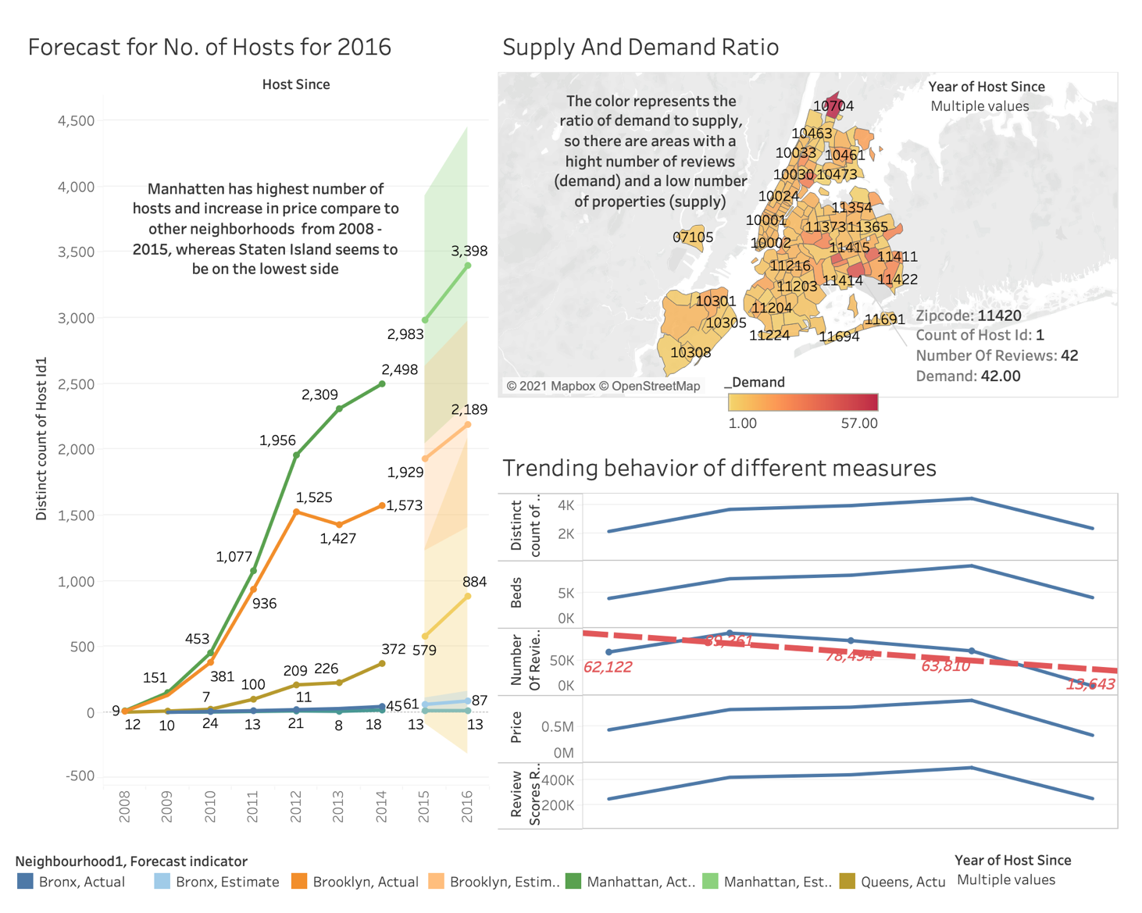

## Dashboard 2

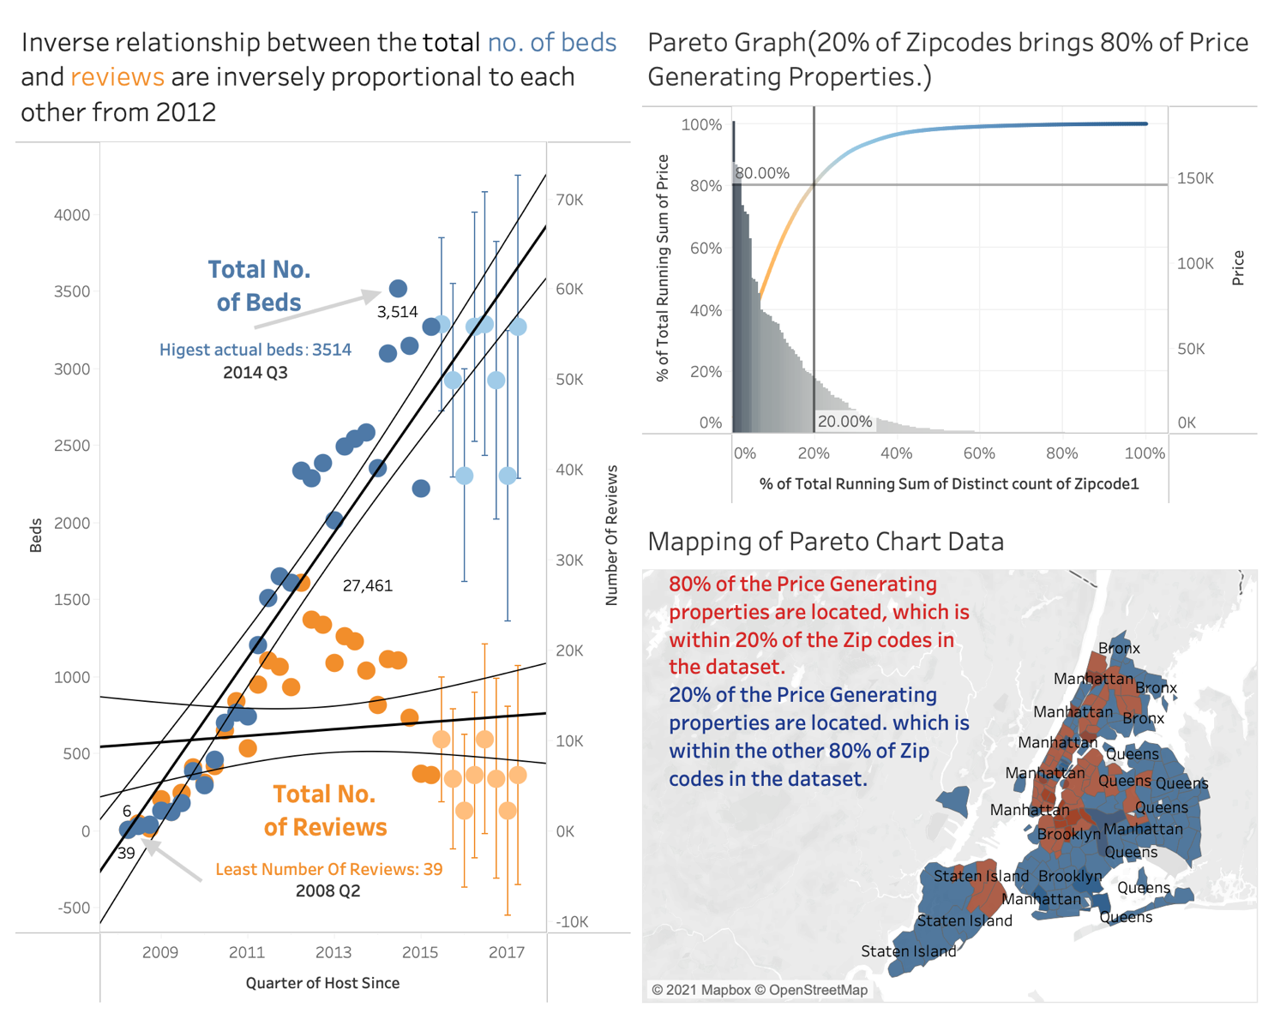

# Purvi Jain

## Why number of hosts reducing after 2014?

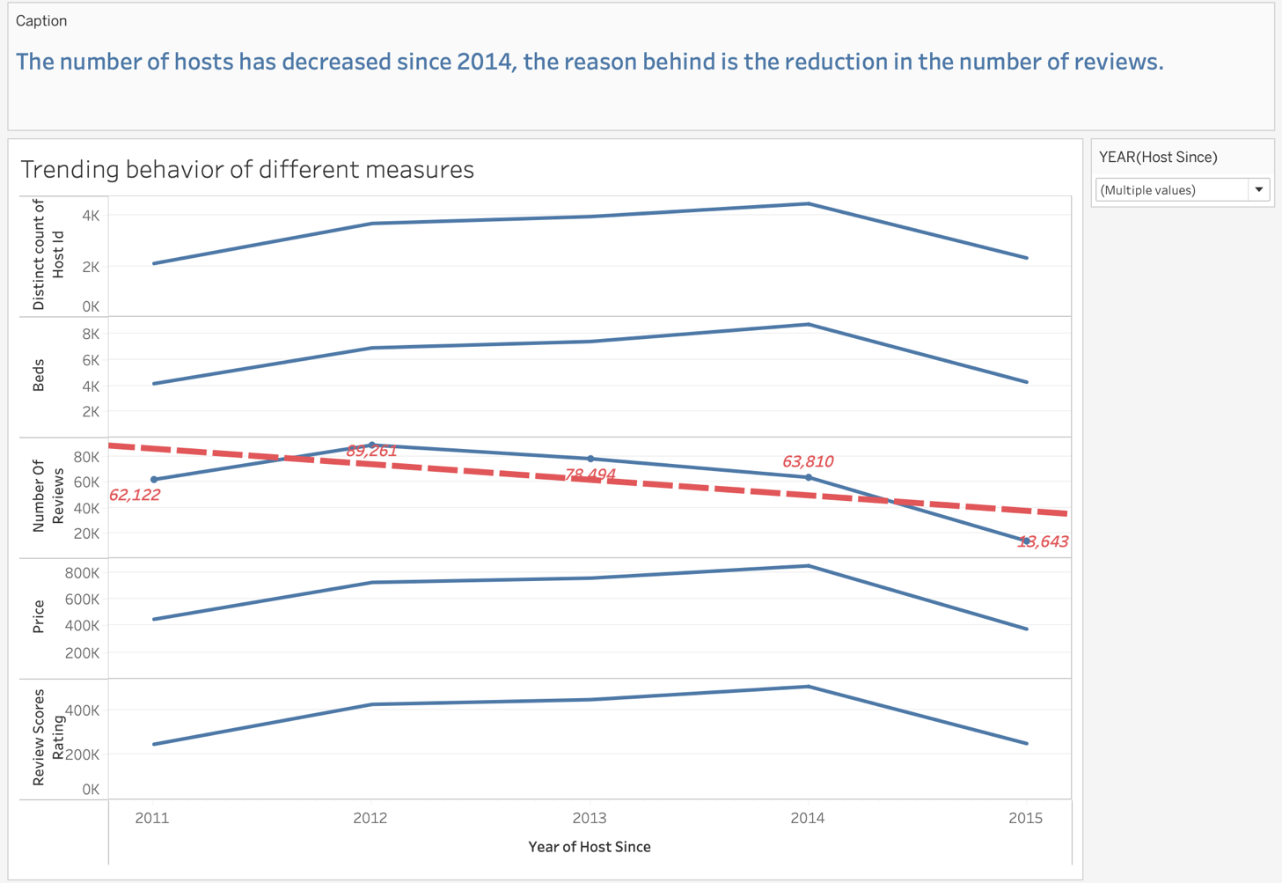

Insights:

The measures: Number of beds, Number of review scores rating, Price, Distinct count of Host Id trends to go up during year 2012-2014 but the number of reviews is following a downtrend which seems the reason for downtrend of the number of hosts the next year thereby reducing number of beds, number of reviews, price and review score rating.

# Daniyar Kurmanbayev

## Where is it better to increase the number of properties?

## Insights:

This map shows the demand to supply ratio in zip codes for the last two years. In most of the zip codes, the ratio is closer to 1, but there are zip codes with high demand and a low number of properties. So, these areas should be prioritized for the increasing number of hosts and properties.

# Shanka Attanayake

## Pareto Graph (20% of Zip codes have 80% of Price Generating Properties.)

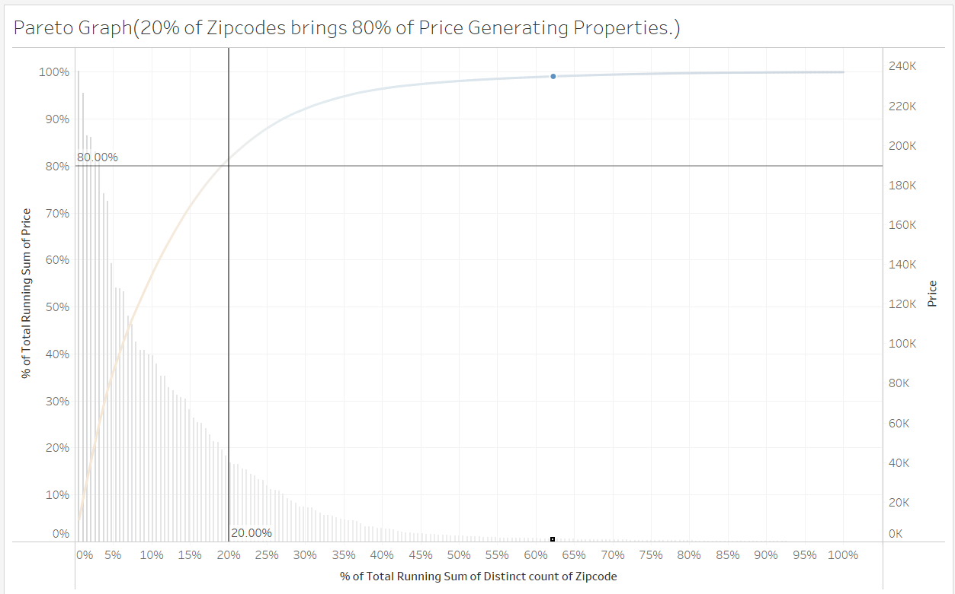

## Mapping of Pareto Chart Data

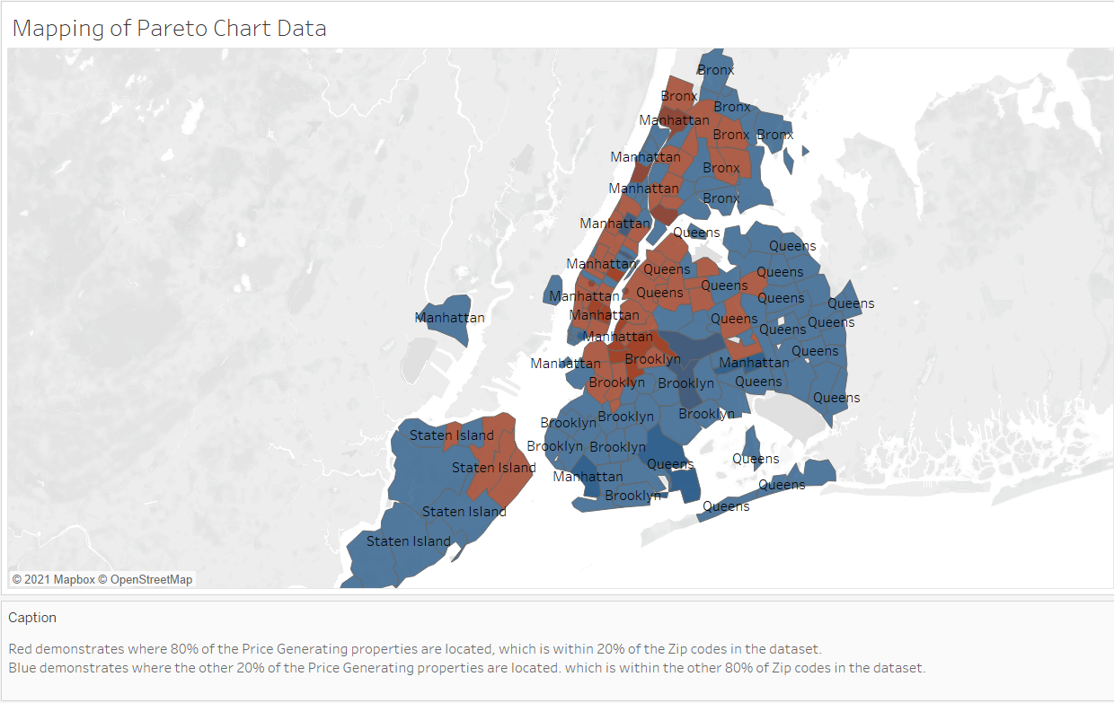

## Insight:

In this visualization, it proves the pareto chart to be true, where 80% of all the price generating properties are within 20% of the zip Codes. This was completed by finding the Running Total of all the Zip Codes and finding the Percent of Total. With is information we can research more on how we can maximize in those areas because they seem to be the most in demand areas within the dataset.

Additionally, the mapping of the Pareto chart data demonstrates that most of the price-generating properties are within the center of the city and the number of price-generating properties in a specific zip code reduces as the zip code is farther away from the center of the city. Although, there is an increase in properties in the zip codes in Staten Island where the Ferry terminals are located.

# Vrinda Parameswaran:

## Hosts in a neighbourhood forecast:

Insights:

This visualization was intended to check the trend number of hosts in a neighborhood over years 2008 to 2015 and to forecast it in 2016.

Manhattan had very good results with good number of hosts increasing over the years, whereas Staten Island didn’t show the same kind of progress. So, we must work on increasing the number of reviews.

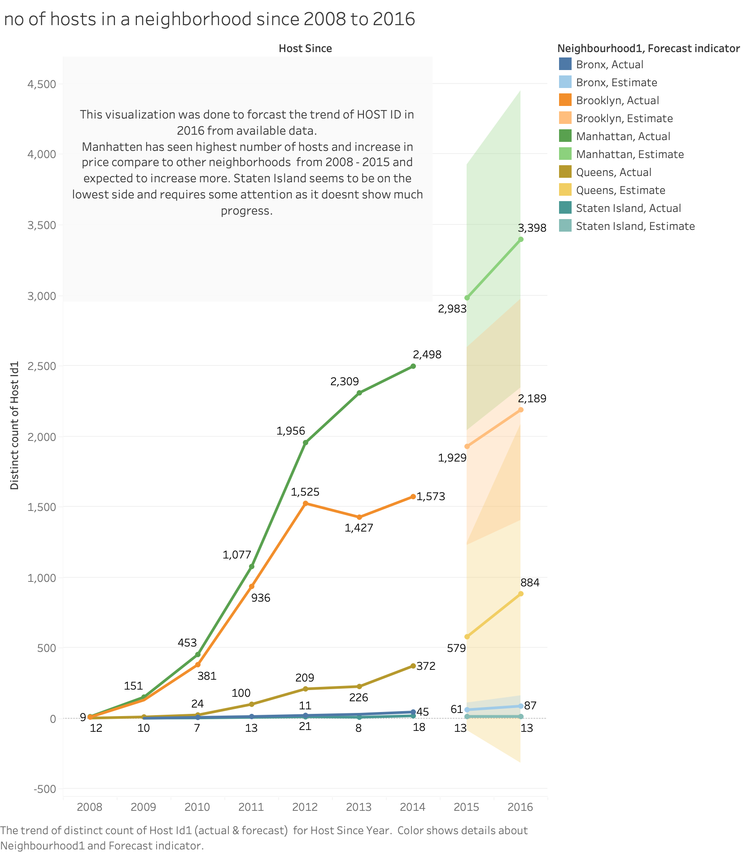

## Host with Maximum number of reviews:

Insights:

The visualization was done to find the host with the greatest number of reviews in 2015.

# Tanvir Singh Ahuja:

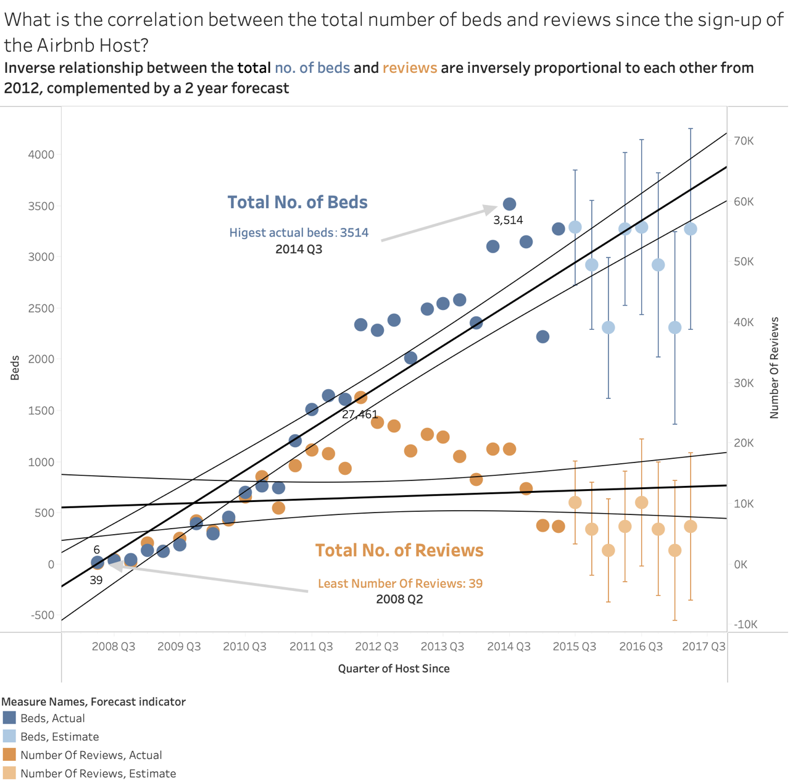

## Insights:

This visualization shows

- The Inverse relationship between the total number of beds.

- The reviews are inversely proportional to each other from 2012.